Benha University, Faculty of Science
Post-Graduate Examination
Subject: Remote Sensing technique
Date: 05.06.2017
Time Allowed: 2h

Answer Model of Remote Sensing course

- Write on the Energy-Atmosphere interaction in remote sensing technique?

- EM radiation used for remote sensing has to travel through some distance of the particles and gases in the atmosphere which can affect the incoming light and radiation. These effects are caused by the mechanisms of scattering, absorption and transmission. Scattering occurs when particles or large gas molecules in the atmosphere interact with the electromagnetic radiation and redirects it from its original path.
- How much scattering takes place depends on several factors including:
  - The wavelength of the radiation,
  - The abundance of particles or gases,
  - The distance the radiation travels through the atmosphere.
- There are three (3) types of scattering which take place.
Rayleigh scattering
- Rayleigh scattering occurs when particles are very small compared to the wavelength of the radiation.
- These could be particles such as small specks of dust or nitrogen and oxygen molecules.
- Rayleigh scattering causes shorter wavelengths of energy to be scattered much more than longer wavelengths.
- Rayleigh scattering is the dominant scattering mechanism in the upper atmosphere.
- The fact that the sky appears “blue” during the day is because of this phenomenon.
Mie Scattering
- Occurs when the particles are just about the same size as the wavelength of the radiation.
- Dust, pollen, smoke and water vapor are common causes of Mie scattering which tends to affect longer wavelengths than those affected by Rayleigh scattering.
- Occurs mostly in the lower portions of the atmosphere where larger particles are more abundant, and dominates when cloud conditions are overcast.
Nonselective scattering
- This occurs when the particles are much larger than the wavelength of the radiation.
- Water droplets and large dust particles can cause this type of scattering.
- Nonselective scattering gets its name from the fact that all wavelengths are scattered about equally.
- This type of scattering causes fog and clouds to appear white to our eyes because blue, green, and red light are all scattered in approximately equal quantities (blue+green+red light = white light).
Transmission and Absorption
  - Transmission bands (atmospheric windows)
  - Absorption bands (atmospheric blinds)
-----------------------------------------------------------------------------------

- Compare between two well known sensors representing the end members between low and high resolution satellites? The following points should be included: Sensor name, altitude, spatial resolution, spectral resolution, swath and radiometric resolution.

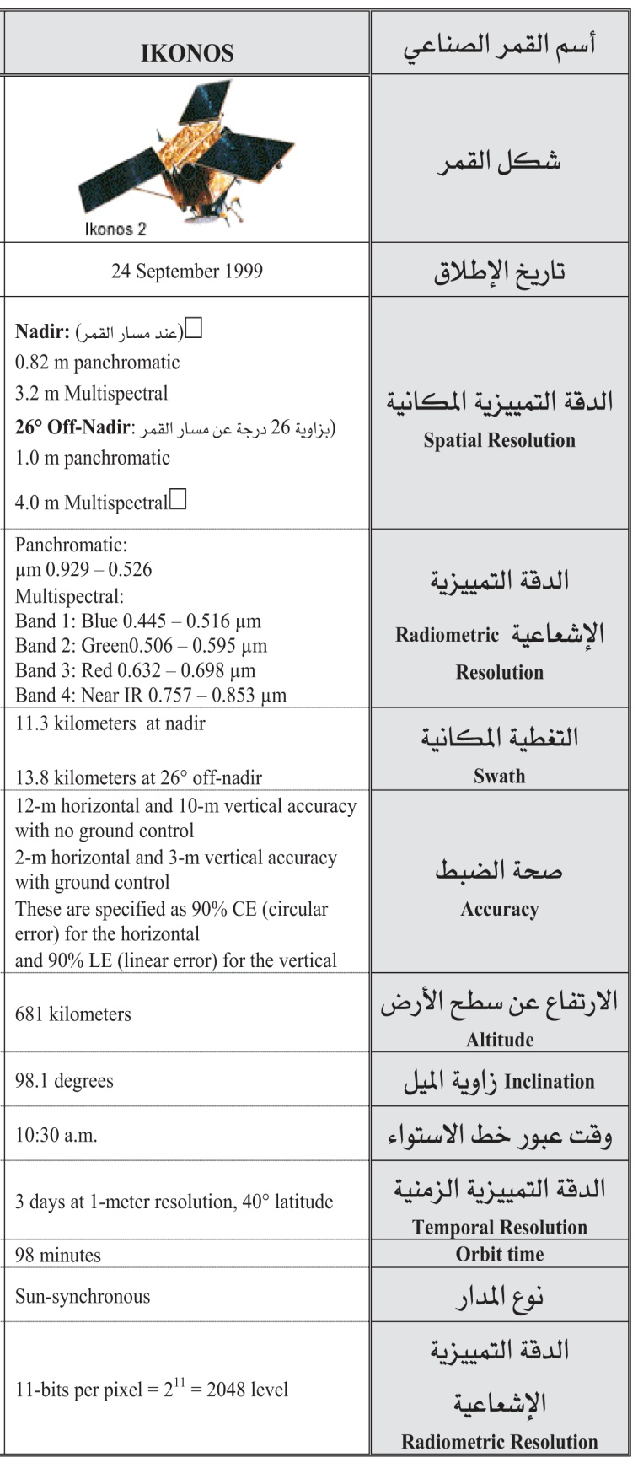
The comparison is preferably arranged in tables as the following diagrams:
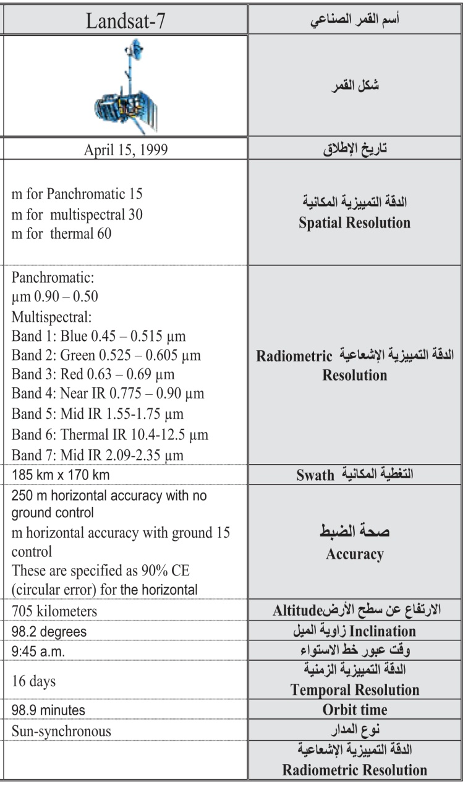

- Give a brief account on:

- A digital image:
It is a rectangular array of horizontal lines. Each line is made of picture elements called pixels. Each pixel has a digital number called DN value. The DN value represents the EM energy that was sensed by a sensor in a certain spectral band (range) from an area (ground spatial resolution cell) on the earth’s surface.

- An Electromagnetic spectrum:
It is the range of wavelengths including the visible light division or band. Our eyes can only see a small part of this energy known as visible light.
----------------------------------------------------------------------------------------
- How pattern, association and texture play great role in image interpretation, give ‘life’ examples?

Pattern
  - Pattern is the spatial arrangement of objects on the landscape.
  - General descriptions include random and systematic; natural and human-made.
  - More specific descriptions include circular, oval, curvilinear, linear, radiating, rectangular, etc.
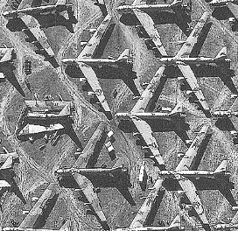

Association
  - This is very important when trying to interpret an object or activity.
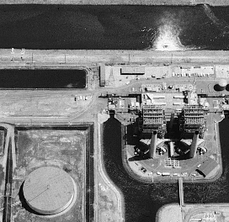
Association refers to the fact that certain features and activities are almost always related to the presence of certain other features and activities.

Texture
  - Texture refers to the arrangement of tone or color in an image.
  - Useful because Earth features that exhibit similar tones often exhibit different textures.
  - Adjectives include smooth (uniform, homogeneous), intermediate, and rough (coarse, heterogeneous).
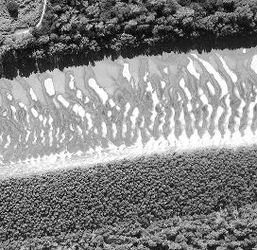

Best wishes
Dr. Wael Dardir Ahmed Hagag

