|  |  |
| --- | --- |
|  |  |
| **Benha university** | **Fourth Level** |
| **Faculty of science** | **special Geology** |
| **Geology Dept.**  **12 / 6 /2016** | **Introduction to Medical Geology**  **and Volcanology (436 G)** |
|  | **Time: Two Hours** |

-------------------------------------------------------------------------------------------------------------------------------

**Model answer of the examination of Introduction to Medical Geology and Volcanology (436 G) for the Fourth level students (Geochemistry), June 2016.**

1. **Discuss the following:**  (12 Marks)
2. **What is asbestos?**

Asbestos is the name given to a group of six different fibrous minerals (amosite, chrysotile, crocidolite, and the fibrous varieties of tremolite, actinolite, and anthophyllite) that occur naturally in the environment. One of these, namely chrysotile, belongs to the serpentine family of minerals, while all of the others belong to the amphibole family. All forms of asbestos are hazardous, and all can cause cancer, but amphibole forms of asbestos are considered to be somewhat more hazardous to health than chrysotile.

1. **What happens to asbestos when it enters the environment?**

Asbestos fibers do not evaporate into air or dissolve in water. However, pieces of fibers can enter the air and water from the weathering of natural deposits and the wearing down of manufactured asbestos products. Small diameter fibers and fiber-containing particles may remain suspended in the air for a long time and be carried long distances by wind or water currents before settling. Larger diameter fibers and particles tend to settle more quickly. Asbestos fibers are not able to move through soil. They are generally not broken down to other compounds in the environment and will remain virtually unchanged over long periods.

1. **How can asbestos enter and leave human body?**

When asbestos fibers are breathed in, they may get trapped in the lungs. Levels of fibers in lung tissue build up over time, but some fibers, particularly chrysotile fibers, can be removed from or degraded in the lung with time.

1. **How can asbestos affect human health?**

Low levels of asbestos that present little, if any, risk to your health can be detected in almost any air sample. For example, 10 fibers are typically present in a cubic meter (fibers/m3) of outdoor air in rural areas. (A cubic meter is about the amount of air that you breathe in 1 hour.) Health professionals often report the number of fibers in a milliliter (mL) (equivalent to a cubic centimeter [cm3]) of air rather than in a cubic meter of air. Since there are one million cm3 (or one million mL) in a cubic meter, there typically would be 0.00001 fibers/mL of asbestos in air in rural areas. Typical levels found in cities are about 10-fold higher

1. **Is there a medical test to determine whether someone has been exposed to asbestos?**

The most common test used to determine if you have received sustained exposure to asbestos is a chest x-ray. A chest x-ray is recommended for detecting exposure to asbestos only in persons who have sustained relatively heavy exposure. A chest x-ray is of no value for detecting evidence of asbestos exposure in a person whose exposure to asbestos has been only brief or transient. The x-ray cannot detect the asbestos fibers themselves, but it can detect early signs of lung disease caused by asbestos.

1. **Answer the following questions**  (12 Marks)
2. Classify the following elements into micro- and macro-nutrients and illustrate the action of each element?
3. Iron
4. Copper
5. Zinc
6. Cobalt
7. Magnisum
8. Chromium

**ACTION OF MACRONUTRIENTS**

|  |  |
| --- | --- |
| **Mg** | **In bones, together with Ca; activation of muscular contractions; body temperature control; component of several enzymes.** |

**ACTION OF MICRONUTRIENTS**

|  |  |
| --- | --- |
| **Co** | **Active in vitamin B12 and in chemical reactions. Deficiency causes anemia. Excess causes hearth failures.** |
| **Cr** | **Needed for metabolism of sugar. Deficiency may cause diabetes, intolerance to glycose etc. Excess may result in renal failures. Excess of Cr6 is carcinogenic.** |
| **Cu** | **Component of oxidizing enzymes during metabolism of energy sources; active in the synthesis of hemoglobin, in keratization and in skin and hair pigments. Deficiency leads to osteoporosis and low number of white blood cells.** |
| **Fe** | **Essential component of hemoglobin and enzymatic complexes required for energy generation and immunological system.** |
| **Zn** | **Occurs in all tissues, mostly in bones, muscles and skin; active in the immunological system; regulates body growth; protects the liver. Deficiency reduces body growth.** |

1. It is clear that the biosphere, atmosphere and hydrosphere are currently being altered at rates far surpassing the natural processes. Perturbed systems resulted from this alteration and embody the consequences of human induced forcing of the natural system. **Discuss the Processes Causing Perturbed Systems?**

* Perturbed systems resulted from this alteration and embody the consequences of human induced forcing of the natural system.

This has resulted from global warming, acid rain and acid mine drainage and long range transport of materials amongst others.

* **Global Warming:** An example of human activities is the release of gases like CO2 into the environment illustrated using the

Carbon Cycle in next figure causing a change in the cycle of this element.

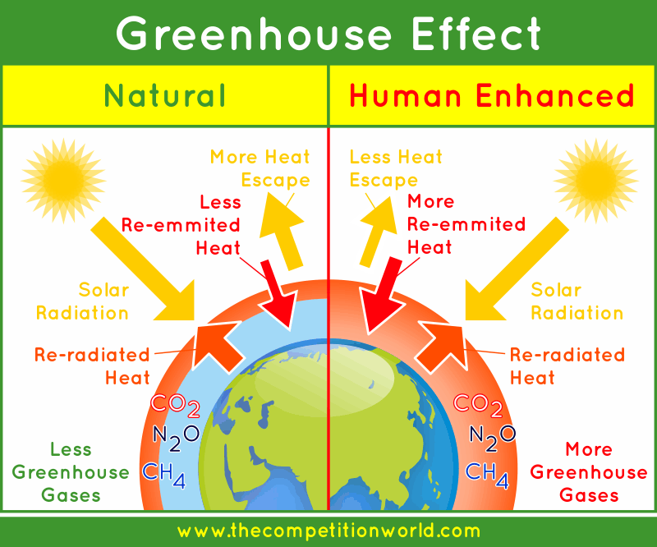CO2 and certain other gases such as H2O in the atmosphere called the greenhouse gases interact with incoming energy from space by absorbing and reemitting it back to maintain atmospheric temperatures alike a greenhouse sustains temperatures.

An increase in the amount of greenhouse gases increases the amount energy retained as the more is absorbed causing the atmospheric temperature to rise as shown in THE Figure. The increased temperatures cause environmental changes affecting global weather patterns causing change in climatic systems.

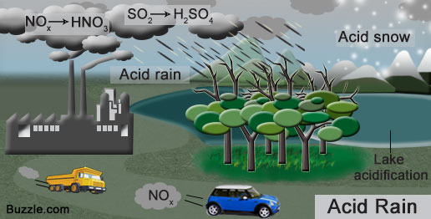**Acid rain:** Acid rain consists of acids from the atmosphere that fall dissolved in rainwater as shown in Fig. below. Gases like SO2 and NO released into the atmosphere react with H2O, O2 and others resulting in mild acid solutions which

precipitate as rain affecting plants and animals.

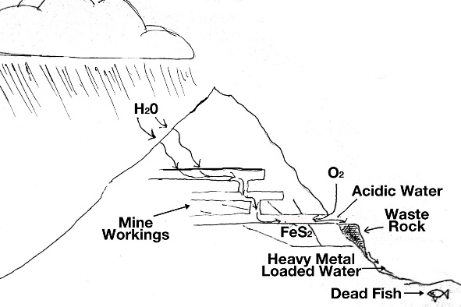**Acid Mine Drainage:** This is a highly acidic drainage flowing from mine edits or waste piles with high concentrations of dissolved metals formed by geochemical reactions occurring due to the exposure of the mineral pyrite to air. The metals stay dissolved in solution until the pH rises to a level when they precipitate as bright orange colour precipitates as seen in Fig. below.

The understanding of the geology of mineral deposits and geochemical processes responsible for elemental mobility is necessary to overcome health impacts of the development of mineral resources.

1. **Explain the following:** (12 Marks)
2. **The controlling factors of the magma`s viscosity**

**Controls on Viscosity**

***1. Silica composition***

The strong dependence of viscosity of molten silicates on Si content can be illustrated by those of various Na-Si-O compounds:

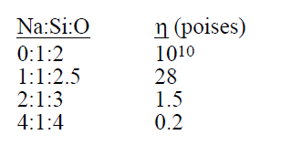

The decrease in viscosity can be attributed to a reduction in the proportion of framework silica tetrahedral, and therefore, strong Si-O bonds in the magma.

***2. Temperature***

Temperature has a strong influence on viscosity: **as temperature increases, viscosity decreases, an effect particularly evident in the behavior of lava flows.** As lavas flow away from their source or vent, they lose heat by radiation and conduction, so that their viscosity steadily increases.

***3. Time***

At temperatures below the beginning of crystallization, ***viscosity also increases with time.*** If magma is undisturbed at a constant temperature, its viscosity may continue to increase for many hours before it reaches a steady value. The viscosity increases with time results partly an increasing proportion of crystals (which raise the effective magma viscosity by their interference in melt flow), and partly from increasing ordering and polymerizing (linking) of the framework tetrahedra.

***4. Volatiles***

The solubility of gases in magmas varies with pressure, temperature and composition of both the gas and the magmatic liquid. Because the volume of a melt with dissolved gas is less than that of a melt and separate gas (vapor) phase, solubility increases as gas pressure increases. At constant gas pressure less than total pressure, any increased load pressure on the melt lowers solubility, because the volume of the melt with dissolved gas is greater than that of melt alone.

**Vapor pressure increases with temperature**, so that solubility of any **volatile component generally decreases with temperature, except possibly at high pressure**. Nearly all magmas can contain more water or gases at depth than they can continue to hold in solution when they reach the surface.

***5.*** ***Pressure***

The effect of pressure is relatively unknown, **but viscosity appears to decrease with increasing pressure** at least at temperatures above the liquidus. As pressure increases at constant temperature, the rate at which viscosity decreases is less in basaltic magma than that in andesitic magma.

***6. Crystal content***

The effect of suspended crystals is to increase the effective or bulk viscosity of the magma.

***7. Yield Strength***

As yield strength increases, the stress required to initiate and sustain flow becomes greater, and the magma's apparent or effective viscosity is also increased.

8. ***Specific Heat***

The specific heat (Cp) of magma, which is the heat required to change the temperature of the liquid 1 degree Celsius. The specific heat contrasts greatly with heat of fusion or crystallization, which is the heat that must be added to melt or removed to crystallize a unit mass that is already at a temperature where liquid and solid coexist.

***9. Thermal Conductivity***

Igneous rocks and liquids are poor conductors of heat. Thermal conductivity depends on two heat transfer mechanisms:

(1) ordinary lattice or phonon conduction; and,

(2) radiative or photon conduction.

***10. Density***

Magma densities range from about 2.2 gm/cm3 for rhyolite to 2.8 gm/cm3 for basalts, illustrating a close density-melt composition relationship, primarily reflecting the influence of higher concentrations of Fe, Mg and Ca cations in basalts. In contrast, ***magma density decreases with increasing temperature and gas content***. These densities increase a few percent between liquid and crystalline states.

***11. Electrical Conductivity***

Electrical conductivity, which is low in pure silica melts, ***increases with increasing abundance of metallic cations, especially alkali elements***, and increases abruptly in the melting range.

1. **Nature of the Gaseous Eruptive Column**

**(*1) Temperature Relations:*** Exsolution and expansion of gas significantly cools magma as it rises. If there is good thermal equilibration between the magma and gas, the extent of cooling can be very great, e.g. there can be 300°C cooling of a vesiculating basaltic magma, if it expands adiabatically from the pressure at which gas exsolution begins. The temperature of the gas is largely dependent on the proportion of the two phases, and the efficiency of the heat exchange. The latter is strongly dependent on size because only ejecta or magma fragments less than 5 mm can attain thermal equilibrium with the gas during an eruption; silicate particles therefore account for most of the heat. If the source of the gas is meteoric water, the heat used to flash the water to steam tends to buffer the temperature eruption at around 100°C. As the eruption column emerges from the vent, it continues to cool as it expands and mixes with air.

***(2) Density Relations:*** The density of the eruptive column influences its capacity to carry fragments suspended in the gas stream. The smaller particles are subject to drag forces larger than their inertial forces, and thus, have lower terminal velocities so that they behave like gas particles. Particles less than 0.1 mm in diameter have so low terminal velocities compared to the velocity of the gas stream, that they contribute to the effective density and viscosity of the eruption column. A greater proportion of fine particles therefore enhances the ability of the eruption column to support large clasts or fragments.

***(3) Viscosity Relations***: A marked increase in magma viscosity occurs as a result of falling temperature and reduced water content during eruption. As a consequence, there is a slower expansion rate of bubbles as the magma approaches the surface. Conversely, the increased proportion of gas lowers the overall viscosity if the gas phase becomes large enough to be continuous.

The flow velocity of lava flows depends on a number of different factors:

(i) rate of effusion, (ii) magma viscosity, (iii) volume of magma extruded, (iv) magma density, and, (v) the slope and nature of the channel in which it flows.

As expected, flow velocity diminishes with distance from the source. A pronounced velocity gradient exists within lava flows, extending from the middle toward the top, bottom and sides. Without a surface crust, the fastest movement occurs in the upper and middle parts of the flow, but once a crust forms, the fastest-moving part moves increasing downward into the lava.

1. **External Structures of Aa Lavas**
2. *Lava Gutters*: These channels develop when faster-moving parts of the flow drain away from slower-moving parts and flow bottom as the supply of lava diminishes or stops.
3. *Lava Levees*: These longitudinal ridges develop by accretion of lava on the slower-moving parts or flanks of the flow, generally bounding the central gutter.
4. *Lava Lobes*: These features represent lava tongues that have generally developed along flow margins after the levee is breached.
5. *Accretionary Lava Balls*: These structures form, like snowballs, by the rolling up of solid fragments, either clinker or chunks, derived from the walls of the flow channels, and typically range in diameter from a few cm to 3 m.
6. **Discuss in detail** . (12 Marks)
7. “Mechanism of Explosive Eruptions”

**The major factors which determine the explosivity are:**

(a) the rate of gas expansion, and,

(b) the manner in which expansion occurs.

**These factors, in turn, depend upon** the viscosity of the magma, and the way in which they vesiculate. The degree of vesiculation and gas expansion may vary throughout an eruption.

Following a period or repose, initial eruptions usually therefore involve a gas-rich magma.

Thereafter, the volatile content declines as gases escape to the atmosphere, and viscosity increases as more gas-poor magma is tapped. Low-density gas, either juvenile (magmatic) or meteoric (groundwater), concentrates in the upper parts of the plumbing system or reservoir by diffusing through a narrow boundary layer, through convective processes or by vesiculation and rise of bubbles. Once a magma becomes saturated, it may rise and reach a level at which the pressures exerted by the overlying rocks are low enough to permit vesiculation.

Expansion accelerates the rise of magma, so that the pressure of the overlying rock column is reduced at a faster rate, and eruption ensues. This process by which a reduction of lithostatic pressure allows an increase in exsolution of gas from the magma is known as **"second boiling".**

Vesiculation could also be initiated by convective overturning of an density-stratified magma, or by injection of hotter magma (remember that, in both cases, a resulting temperature increase decreases gas solubility).

1. The major differences between Aa- and Pahoehoe- Lavas

|  |  |
| --- | --- |
| **Aa Lavas** | **Pahoehoe Lavas** |
| high volume flow rate | low volume flow rate |
| high flow-front velocity | low flow-front velocity |
| forms large channels | forms lava tubes |
| few, large flow units | innumerable flow units |
| thick flow units (2-10 m) | thin flow units (0.2-2 m) |
| higher viscosity | lower viscosity |
| slightly cooler | slightly hotter |

**-Good Luck-**

**Dr. M. M. Mogahed**