Benha University, Faculty of Science
4th Level Examination (Geology)
Subject: Structural Analysis (G444)
Date: 31.05.2017
Time Allowed: 1h

Answer the following questions (8 marks for each):
- Give a brief account on the interference patterns of folds (sketches are recommended)
Complex interference patterns of folding are generated by superimposing a set of flow folds on a previously folded surface. The geometrical pattern depends on the spatial relationships between the attitudes of the two fold axes and axial planes, and on the shear or flow direction of the second folds. Three common types of interference patterns produced on a flat surface by superimposition of fold sets. These are: domes and basins (a), crescent shape and mushroom (b), and double zig-zag (c).
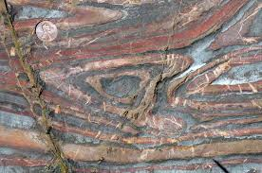
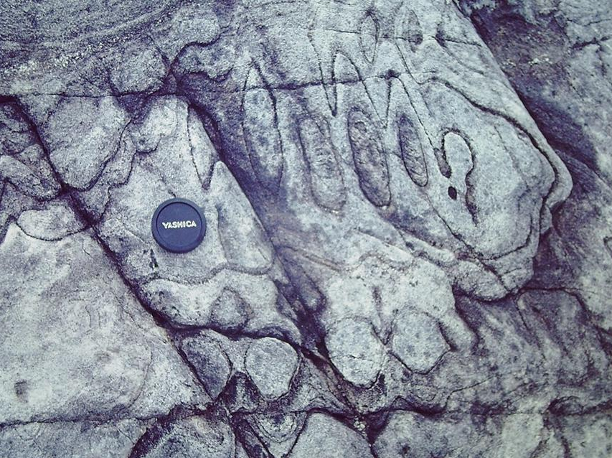
b
a

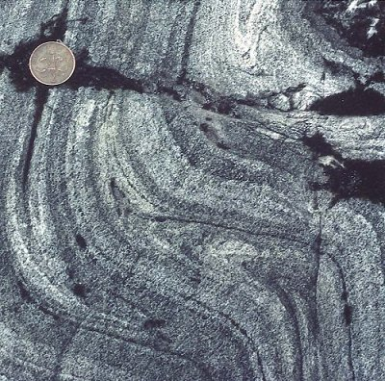
c

- Define the rock foliation and lineation, and explain in detail one example in each type.

A foliation: Is a set of new planar surfaces produced in a rock as a result of deformation.
Example: Crenulation Cleavage (a) is caused, as its name, by small-scale folding (crenulation) of very thin layers or laminations within a rock. If the axial surfaces of such crenulations are closely-spaced and parallel they produced a marked foliation. This foliation is often enhanced by selective recrystallization leading to a concentration of certain constituents in layers like Qz, Mica and feldspars.
-------------------------------------------------------------------------------------
A lineation: Is the linear counterpart of a foliation, which is a set of linear structures produced in a rock as a result of deformation.
Example: Intersection Lineation (b) is one of the commonest types of lineation formed when two sets of planar structures intersect. It is often found at the intersection of bedding and cleavage or of two foliations, a schistosity and a crenulation cleavage. Such intersection lineation is most probably parallel to the local fold axes and crenulation lineations which belong to the same phase of deformation.
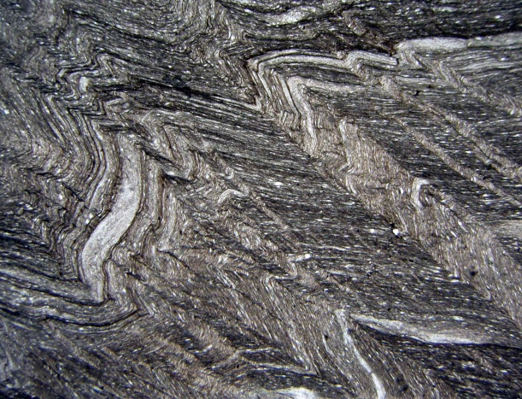
b
a
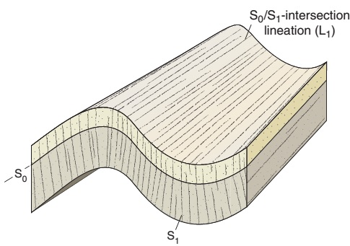

- How can a fold be analyzed using the stereographic projection technique (please, brief discussion with illustrates).

Folds can be analyzed using the stereographic projection technique by plotting the different strike/dip readings measured on both two limbs (flanks) of the fold on the stereographic net in the form of (1) pole-to-bedding or foliation plots ‘pi-diagrams’, (2) cyclographic plot ‘beta-diagrams’. Many sets of data can be interpreted, then, especially from the distribution of poles on the pi-diagrams like attitude of axial plane and fold axis, fold symmetry and inter-limb angle.

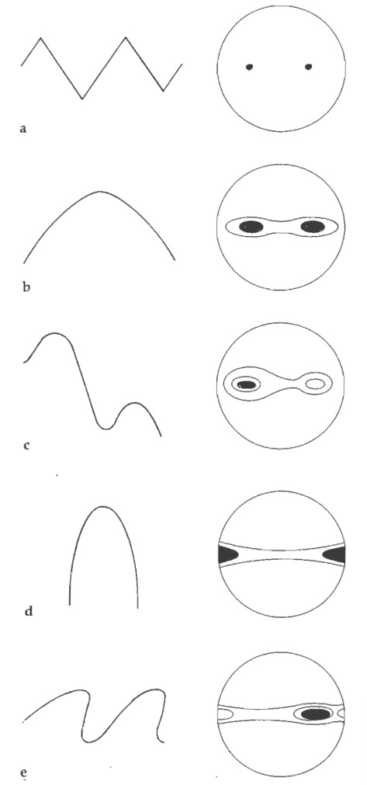

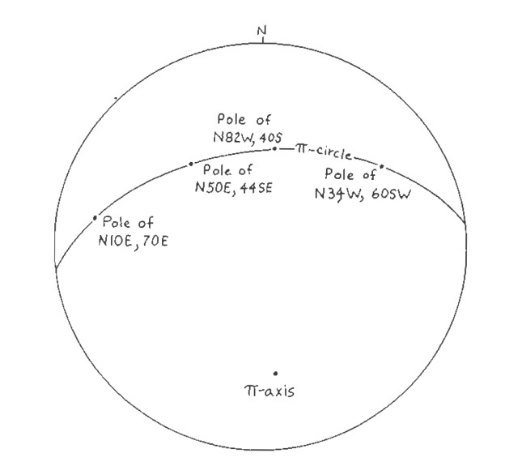

- Pi-diagram showing the distribution of poles of foliation of a cylindrecal fold

(B) Profiles and contoured Pi-diagrams of variously shaped folds

Good Luck
Dr. Wael Dardir Ahmed Hagag

