Benha University 3rd year – Physics.

Faculty of Science Second term - May 2017

Physics Department Date : 6/6/2017

Plasma Physics (Phys 332) Time : 3 Hours

***اجابات* امتحان الفصل الدراسي الثانى للعام الجامعي 2016/2017**

**أ.د/ محمد علي عطيه - قسم الفيزياء- كلية العلوم – *ورقة كاملة***

**Answer ALL questions:**

**1st Question** **Choose the correct answers:** [10 Marks]

1- If the voltage across Rogowski coil is V, which of the following is correct:

a) V **** RC b) V **** R/C d) V **** ʃ I dt **d) V  dI/dt**

2- By a 2 eV plasma we mean that:

1. kT = 3 eV **b) kT = 2 eV** c) kT = 4 eV d) kT = 5 eV

3- Finite electric and magnetic fields affect the plasma, the guiding center speed Vgc is given by :

a) Vgc = B / E b) Vgc = 2B / E c) Vgc = B /2 E d) Vgc = E / B

4- The Debye shielding length decreases with increasing…….

a) electron temperature b) ion temperature

c) electron density d) plasma temperature

5- After breakdown of the gas has occurred, the discharge current varies with the

…………………

a) electron temperature b) gas pressure

c) electron density **d) discharge voltage**

6- In glow discharge experiment most of the potential between the two electrodes

dropped across ………….

a) negative glow region b) positive column region

c) Faraday dark space region **d) cathode fall region**

7- The negative glow and the cathode fall regions are compresses at…….

**a) high pressure** b) low pressure

c) very low pressure d) atmospheric pressure

8- Plasma particles tend to reduce the magnetic field, hence plasmas are ……….

a) paramagnetic **b) diamagnetic** c) ferromagnetic d) none of these.

9- In ………. plasma all temperatures are equal.

a) local thermodynamic equilibrium (LTE) b) non LTE

**c) complete thermodynamic equilibrium (CTE)** d) non CTE

10- In cold plasma the ion temperature is equal to the ………..

**a) gas temperature** b) electron energy c) electron temperature d) ion density.

**2nd Question** **Rename the following processes:** [10 Marks]

1. A+ + B → A + B++ K.E.

Ion-atom collision (charge transfer)

1. A + hυ → A+ + e

Photo-ionization process

1. A* + e → A+ + 2e

Double electron impact

1. A + B → A+ + B+ + 2e

Atom-atom collision

1. A+ + e → A* + h*v*

**Recombination process.**

**3nd Question** **Complete the following sentences:** [10 Marks]

1. The plasma state can be defined as a quasi-neutral gas of charged and neutral particles which exhibits collective behavior.
2. The width of the Maxwellian distribution is characterized by the constant T, while the area under the distribution curve represents the plasma density.

LTE plasmas can exist under two circumstances: 1- **When the heavy particles are very energetic,** 2- **When the pressure is atmospheric**

1. The negative glow and the cathode fall regions of the glow discharge are compresses at high pressure.
2. Rogowsky coil is used to determine the high discharge current while the potential divider is used to determine the high voltage across the plasma.

**4nd Question** Differentiate between the following: [20 points]

1. Motion of charged particles in gradient B drift (∇BB) and in magnetic mirrors (∇B║B).
2. Gradient B drift (∇BB): Consider a magnetic field Bz(x) with a gradient  perpendicular to the lines of B, as shown in Fig. below. Viewing the motion of a gyrating particle in the x–y plane , we see that there is a stronger Lorentz force at the upper half of the orbit than at the lower half, producing a smaller gyration radius at the upper half than at the lower, and leading to a net drift along y.

Fig. Perpendicular gradient drift due to a magnetic field gradient 

(a) the magnetic field lines; (b) the motion viewed in the x–y plane.

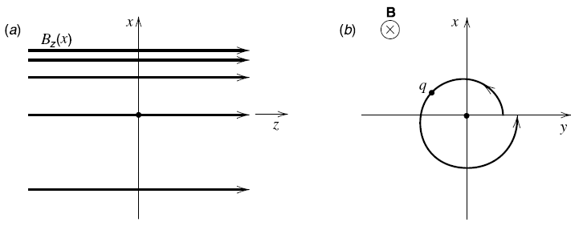

1. Magnetic mirror :- In this case, the magnetic field lines converge as shown in Fig. below and the Lorentz force qv┴×B has a component along z given by

*F*z = – q v *B*r

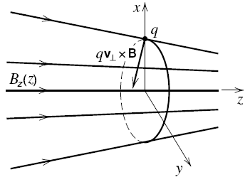

Fig. Parallel force due to a magnetic field gradient.

1. A Rogowsky coil with winding density of 1200 turns/m and cross sectional area of a single turn 1.6 cm­2 was connected to RC integrator (R= 8.4 kΩ and C = 5.2 μF). If the output voltage is equal to 4.8 V then :

What is the value of the current passes through the major axis of the coil?



= (1.6x10-2x1200 x I)/(8.4x5.2x10-6) = 4.8 V

I = 2096.6x10-6 /19.2 = 1.1 x 10-4 A

**5nd Question** **Answer three only of the following questions:**  [30 Marks]

1. "Plasma is an ionized gas but any ionized gas cannot be called plasma", explain this statement.

It's true, any ionized gas cannot call plasma, and there is always small amount of degree of ionization. So, the ionized gas must obey two conditions: quasineutrality and collective behavior.

1. If the gas pressure of glow discharge experiment is equal to 200 Pascal. Calculate the degree of ionization knowing that the ion density = m-3.

P = 200 x 0.0075 = 1.5 torr ,

S = ni/nn

nn = 1.6x1016 P , P in torr = 1.6x1016x 1.5

= 2.4x 1016 m-3

S = 1x1014/2.4x1016

= 0.0042

1. Compute the cyclotron frequency and Larmor radius for a solar wind proton with streaming velocity 520 km/s , where B = 0.18 T.

The cyclotron frequency : 

Larmor radius:



1. write short note about:
2. The Z-pinch device.

The Z pinch devices consist mainly of two flat electrodes, between which the plasma is formed. The capacitor bank Co is discharged via the circuit inductance Lo , the switch S, and the discharge chamber. When the switch S is closed, the charging voltage V appears across the two electrodes. During the ignition process, the breakdown occurs and a current sheath is formed. Then, the current I, the generated magnetic field B increase and the sheath compressed by Lorentz force F towards the center axis of the chamber. In this phase, the current begins to move in the axial direction (Iz) and the magnetic field still in the azimuthal direction (Bθ) so that Lorentz force is deflected to the radial direction (Fr). Finally, the current sheath collapses forming what is called the focus or pinch. The pinch process is characterized by its extremely high energy density and for being a rich source of other phenomena like emission of intense radiation and high energy particles. The main heating mechanism inside the plasma before the front of the current sheath meets along the z-axis is referred to shock heating. The piston compressed the shock heated plasma toward the axis, heating it to higher temperature.

1. The factors affecting the glow discharge regions.

1- Effect of the gas pressure

The pressure of the gas in the discharge tube has a significant effect on the relative length of the various regions of the glow discharge. Generally, the glow discharge is operated at a pressure of less then 100 torr. At the high pressure end, the positive column is favored. The negative glow and the cathode fall regions are compresses at high pressure while the positive column extends to fill the space between the electrodes. However, its radial dimension also shrinks and it becomes not in contact with the wall of the glass tube anymore.

2- Effect of the electrodes separation

1. Effect of the discharge current
2. Effect of the type of gas used

**Physical Constants:**

h = 6.62 × 10–34 J.sec e = 1.6 × 10–19 C electron mass = 9.1×10–31 kg

k = 1.38 × 10–23 J/K c = 3 × 108 m/s proton mass = 1.67×10–27 kg