Time: 2 h
Date: 20 / 6 / 2017
Code: Chem. 337

Benha University
Faculty of Science
Chemistry Department

Applied Electrochemistry (1) Exam. for 4th Year Students (Major Chemistry)

Answer the following questions:
- Choose the right answer in the following: (24 marks}
- Galvanic cell is defined as:
- A cell which converted the electrical energy to chemical energy.
- A cell which converted the chemical energy to electrical energy.
- A cell which converted the electrical energy to heat energy.
- If the metal has a curved surface:
- The more highly convex surface is the anodic area.
- The less highly convex surface is the anodic area.
- The more highly convex surface is the cathodic area.
- In the electromotive series the tendency of metal ions to electro-deposition:
- Increases as going from the top to the bottom of the series.
- Decreases as going from the top to the bottom of the series.
- Increases as going from the bottom to the top of the series.
- In the electromotive series:
- The metal which has a less negative E^{O} will easily to corrode.
- The metal which has a more negative E^{O} will easily to corrode.
- The metal which has a more negative E^{O} will easily to deposit.
- In the thermodynamic stability diagram of water the area below the line of equilibrium potential of hydrogen represents:
- The decomposition of H₂O and OH⁻ is obtained.
- The decomposition of H₂O and H⁺ is obtained.
- The formation of H₂O from the combination of O₂ gas and H⁺ ions.
- In normal hydrogen electrode, platinized platinum electrode is used due to:
- It is an inert electrode. .
- The ease with which electron transfer occurs on its surface. .
- Both the two (a) and (b). .
- In galvanic series:
a) Metals in the top are noble while those in the bottom are active.
b) The effect of pH on the corrosion was taken in consideration.
c) The corrosion of metals depends not only on their positions in the series but also on their polarization behavior in the different environment.
8) The corrosion tendency of the metals increases as:
a) The amount of impurities in the metal decreases.
b) The amount of impurities in the metal increases.
c) The amount of impurities in the metal has no effect on corrosion.

9) The dissolution of metals will occur spontaneously if:
a) ∆G has +ve value. b) ∆G has –ve value. c) ∆G equals to zero.
10) At equilibrium potential:
a) The current passes in the electrochemical cell is an anodic current.
b) The current passes in the electrochemical cell is a cathodic current.
c) The current passes in the electrochemical cell equals zero.
11) The rate-determining step of an electro-chemical reaction:
a) Is the faster step. b) Is the slowest step. c) Is the moderate step.
12) The mathematical expression of Nernst equation is:
a) ∆Gº = - ZFEº b) E = Eº + RT/ZF ln (a_{O /} a_{R})
c) ∆G = ∆Gº + RT ln (a_{P /} a_{R})
13) The exchange current density (i_{o} ) can be defined as:
a) The rate of oxidation reaction when an oxidation current is passed. b) The rate of reduction reaction when a reduction current is passed
c) The rate of oxidation or reduction of the electrode reaction at its equilibrium state.
14) Activation polarization occurs due to:
a) The concentration gradient between the bulk and the electrode surface
b) The resistance of the electrolyte solution in the electrochemical cell
c) A slow electrode reaction occurs such as hydrogen evolution.
15) Resistance polarization decreases:
a) As the distance between the two electrodes increases
b) As the distance between the two electrodes decreases.
c) Not affected by the distance between the two electrodes.
16) For normal hydrogen electrode:
a) E_{H2} = - 0.0591 pH b) E_{H2} = 0.0591 pH c) E_{H2} = zero
17) In a cell consists of two identical electrodes immersed in the same electrolyte:
a) The electrode which exposed to the lower oxygen will be the cathode.
b) The electrode which exposed to the lower oxygen will be the anode.
c) The electrode which exposed to the higher oxygen will be the anode.

18) In Daniel cell, the cathodic reaction is:
a) The deposition of copper ions, b) The deposition of zinc ions.
c) The dissolution of zinc metal
19) In galvanic cell consists of iron electrode (Eº = - 0.44V) and zinc electrode ( Eº = - 0.76V):
a) Zinc is dissolved. b) Iron is dissolved. c} Zinc ions are deposited.
20) In standard hydrogen electrode, the standard potential E^{O} depends on:
a) The concentration of hydrogen ions in the electrolyte.
b) The pressure of the hydrogen gas. c) Both (a) and (b).
21) In concentration cells composed of two identical electrodes immersed in the same electrolyte:
a) The electrode which in contact with the dilute solution is the cathode.
b) The electrode which in contact with the concentrated solution is the anode.
c) The electrode which in contact with the dilute solution is the anode.
22) If the surface of the metal has different strain:
a) The strained area is usually the cathodic area.
b) The strained area is usually the anodic area.
c) The unstrained area is usually the anodic area.
23) If the metal surface is exposed to differential illumination:
a) The darker region of the surface will be the cathode.
b) The brighter region of the surface will be the anode.
c) The darker region of the surface will be the anode.
24) According to the electromotive series, corrosion of metals in de-aerated aqueous solution is:
a) The reduction of oxygen gas in the electrolyte solution.
b) The reduction of hydrogen ions and hydrogen gas is evolved.
c) The oxidation of hydroxide ions and oxygen gas is evolved.

2- Answer one question only of the following: (16 marks)
a-Sketch and describe the Pourpaix diagram of Fe-H₂O system.
b-What are the different types of polarization. Write in details on concentration polarization.
3- Answer one question only of the following: (4 marks)
a-Sketch and describe in details the calomel electrode.
b-Sketch and describe in details the normal hydrogen electrode.

Model Answer

Answer of question 1:
The right answer:
(1) B (2) A (3) A (4) B
(5) A (6) C (7) C (8) B
(9) B (10) C (11) B (12) B
(13) C (14) C (15) B (16) A
(17) B (18) A (19) A (20) C
(21) C (22) B (23) C (24) B

Answer of question 2a:
Pourbaix diagram of for corrosion behavior of iron – water system is represented in Fig. 1. The
diagram contains three types of straight lines, horizontal, vertical and sloping lines. The horizontal
lines which parallel to the pH axis represents equilibrium does not depend on the pH value. Thus,
lines (1) and (2) represent the following equilibrium reactions, respectively:
- Fe²⁺ + 2 e = Fe
- Fe³⁺ + e = Fe²⁺
Both reactions do not involve H⁺ ions while involve electrons and thus, they have been shown as horizontal lines in Pourbaix diagram. On the other hand, the vertical lines which is parallel to the potential axis represents an equilibrium does not depend on potential value. Thus, electrons do not involve while protons are present in the equilibrium reaction as represented in reaction 3:
- 2 Fe³⁺ + 3 H₂O = Fe₂O₃ + 6 H⁺
The equilibrium reaction which depend on both the potential and the pH value is represented by the sloping line (4): Fe₂O₃ + 6 H⁺ + 2 e = 2 Fe²⁺ + 3 H₂O
It should be noted that the equilibrium reaction involves both protons and electrons. As have be described, Pourbaix diagram gives collected information about different products resulted from the reaction of the metal with the environment, at different pH and potential values. This enables us to predict the corrosion behavior of metal in aqueous medium at a given potential and pH values. The diagram also involves three areas, the area which represented the pure metal indicate that the metal does not react at all with the environment and called immunity area. On the other hand, the area which represents a formation of soluble compound is a corrosion area. The third area is that represents the formation of insoluble compound which acts as a barrier between the metal and the environment and preventing the metal corrosion. This area is called the passive area.
The limitation of the Pourbaix diagram is that , it does not give any information about the rate of corrosion, also the term passivity is used by it for describing the formation of sparingly soluble compounds, however these compounds may be formed but not on the electrode surfsce, and thus they do not give rise to passivation of the metal. Also, the diagram does not take in account the presence of
extraneous ions in the medium or impurities in the metal.
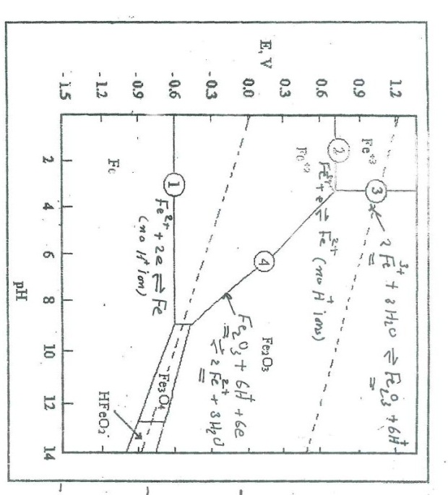

.

Answer of question (2b): There are three types of polarization, resistance or ohmic polarization, activation polarization and concentration polarization.
Concentration polarization:
It is well known that in an electrolytic processes, the concentration of the electrochemically active materials in the immediate vicinity of the electrode is different from that in the bulk of solution, thus in cathodic deposition process, the concentration of metal ions around the cathode is smaller than that in the bulf of the solution and in anodic process the reverse is occurred. During the discharge of cations at the cathode, ions are brought to the electrode surface by three ways: i) ionic migration, ii) diffusion, iii) agitation (stirring or convection). IF the total supply of ions by (i) and (ii) is adequate, there no ionic transport by diffusion, but if the rate of electrolysis exceed that at which ions can be brought by (i) and (iii), then the electrolyte concentration at the electrode surface falls below in the bulk of the solution and ionic transport by diffusion takes place. An equilibrium is then reached in which a concentration gradient exist in a thin layer of solution (d) adjacent to the electrode. The position of this equilibrium is controlled by the rate of diffusion. The activity of the diffusing particles in the bulk is a and that at the electrode surface is a_{e} and the rate of diffusion is proportional with the difference between these two activities and is given by the following relation:
Rate of diffusion = D/d (a – a_{c})
in which D is the diffusion coefficient in cm²/sec. The value of D for most cations are near to the value 7.5x10⁻⁶ cm²/sec for H⁺ and OH⁻ ions they are several times greater than most ions. Besides transport of ions by diffusion, an electrolytic transport according to Faraday,s law occurs according to the following equation: Rate of electrolytic transport = n₊ i / ZF
In which n₊ is transport number of cations, i is current density in ampere / cm² , F is the Faraday constant (96500 coulombs). The total rate of transport (i/ZF) is given by the following relation: i / ZF = D/d (a – a_{c}) + n₊ i / ZF
i / ZF - n₊ I / ZF = D/d (a - a_{e})
(1 – n₊) i / ZF = D/d (a – a_{e})
i = ZFD / (1 –n₊)d (a – a_{e})
From the last equation, as the value of i is increased value of a_{e} decreases and zero value of a_{e} corresponds to the maximum value of i, which is known as limiting current, i_{L}. In this situation, the limiting current is given by the relation:
i_{L} = ZFD a / (1 –n₊) d = ZFD a / n d
where n represents the sum of transport number of all ions which are discharged at the cathode. The last equation can be written as: i_{L} = k a ( where k is a constant)
Practically under the limiting current conditions the electrode potential increases until some different electrode reaction with a great limiting current is able to proceed such as hydrogen evolution. The general form of the relation between concentration polarization (overpotential) and current is shown in the following figure:

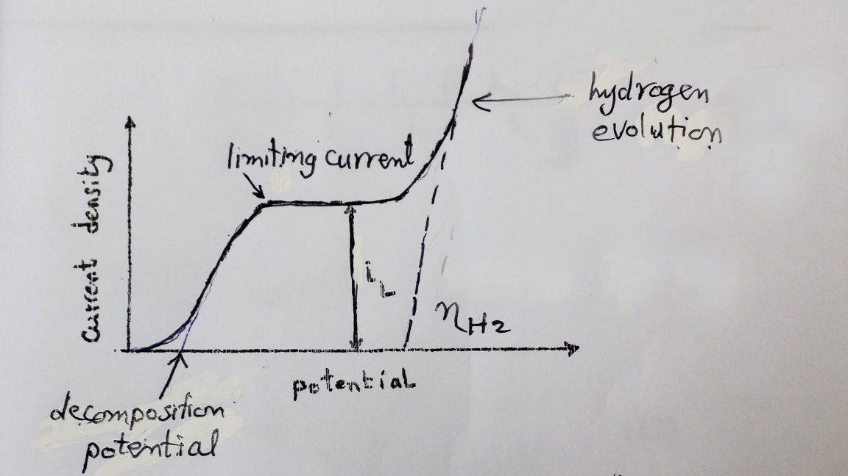

The section of the curve up to the limiting current in the figure is expressed by the following equation: i- At the electrode surface, the potential is given by:
e = eº + RT / ZF ln a_{e}
ii- The reversible electrode potential is given by:
e_{rev} = eº + RT / ZF ln a
The concentration overpotential is given by:
&_{c} = e - e = RT / ZF ln a_{e} / a
By dividing equation 5 over equation 8 we get:
a_{e} / a = i_{L} - i / i_{L}, therefore &_{c} = 2.303 RT / ZF log i_{L} - i / i_{L}

.
Answer of question 3a:
calomel electrode is the most frequently used reference electrode in the laboratory. It consists of a pool of mercury covered with a layer of mercurous chloride (calomel) and immersed in solution of potassium chloride acting as the electrolyte as shown in the following figure. The electric contact to mercury is made by a platinum wire. The overall reaction takes place in calomel electrode is:
Hg₂Cl₂ + 2 e = Hg + 2 Cl⁻
Applying Nernst equation the potential of the electrode can be determined as follows:
E = Eº - 0.0591 log [Cl⁻}
This equation indicates that the potential of the calomel electrode depends on the activity of chloride ions. Three types of calomel electrode containing different chloride ion concentrations are commonly used which are 0.1 N, 1.0 N and saturated potassium chloride, the potentials of which are 0.335, 0.281 and 0.242, respectively. As the concentration of chloride ions is increased the potential of the above electrodes decreases. The temperature coefficient for the three electrodes are - 0.06, - 0.24 and - 0.65, respectively.
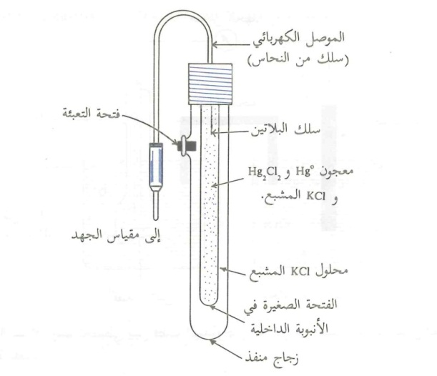
Answer of question 3b:
The normal hydrogen electrode consists of as shown in the following figure , a piece of platinized platinum immersed in a solution of 1.0 M HCl. Pure hydrogen gas is bubbled at the surface of the platinized platinum, at one atmosphere pressure. Hydrogen molecules are adsorbed as atoms at the platinum surface and are able to be ionized from hydrogen ions. The platinized platinum is chosen because its inertness and ease with which electron transfer occurs on its surface. The platinized platinum or platinum black as sometimes may called is prepared by electro-deposition of platinum from acid solution. The electrode reaction can be represented as:
2 H⁺ + 2 e = 2 H_{ads} = H_{2 (g)}
On applying Nernst equation, the potential of the electrode can be obtained as follows:
E_{H}⁺_{/H2} = 0.0 + 0.0591 / 2 log [H⁺] / [H₂]
At one standard atmosphere, hydrogen pressure is unity and then:
E_{H}⁺_{/H2} = - 0.0591 pH

. 

