Benha University
Time: 2 h
Date: 17/ 6 / 2017
Code: Chem. 330
Faculty of Science
Chemistry Department
Irreversible Electrochemistry Exam. for 4th year students (Major Chem.)

Answer four questions only of the following:

- Sketch the free energy diagram of reversible and irreversible electrode process. Based on the electrode kinetics, derive The Tafel equation. (20 marks)
- What are the different types of overpotential. Give a satisfactory account on concentration overpotential. (20 marks)
- Write an account on the hydrogen overvoltage (ƞ_{H}) taking in consideration the principles characteristics of (ƞ_{H}) and the essential stages of hydrogen discharge at the cathode. (20 marks)
- Write a satisfactory account on Stern double layer and the electrokintetic phenomena. (20 mark)
- What are the different methods used to measure the capacity of the double layer. Describe in details the electrocapillary method. (20 mark)

With my best wishes
Prof. Dr. El-Sayed M. Mabrouk

Model Answer

Answer of question (1): For reversible systems, if we consider the following equilibrium of metal electrode with its ions:
M = M^{z+} + z e⁻
The rate of ionization of M atom is equal to the rate of discharge of metal cations M^{z+} , i.e., the net current equals to zero. Metal atoms ionization have attained a minimum amount of free energy and the rate of ionization being dependent on the height of this energy barrier. Similarly, the rate of discharge of metal cations is determined by the height of another barrier differs in height from the first. The following figure represents the energy barrier in the immediate vicinity of the electrode surface. The movement from left to right represents the ionization of metal atoms, the discharge of metal cations is represented by a movement from right to left over energy peak which corresponds to an intermediate. This intermediate is known as the activated state which is characterized by what is known as free energy of
activation, ∆G₁ or ∆G₂ for each direction of the reaction. The difference between these two free energies of activation is the free energy of the reaction ∆G which is simply related to the reversible electrode by the expression: ∆G = G₂* - G₁* = - ZeF
All particles reaching the activated state complete their reaction path to the final product, the rate of ionization is given by: V₁ = k₁ e ^{– (∆G}₁^{* / RT)}
Where k is a constant, depending on activities, temperature and nature of metal. On the other hand, the rate of discharge V₂ of metal cations is given by: V₂ = k₂ e ^{– (∆G}₂^{* / RT)}
k₂ is a analogous to k₁ . Since the system is reversible and at equilibrium:
V₁ = V₂ . i.e, k₁ e ^{– (∆G}₁^{* / RT)} = k₂ e ^{– (∆G}₂^{* / RT)}
k₁ / k₂ = e - ^{(∆G}₂^{* / RT} = e ^{– (∆G* / RT)} = e ^{ZeF / RT}
For irreversible processes, the electrode potential departs from the reversible value by an amount (ƞ) which is the polarization or overpotential. Part of (ƞ) accelerates the dissolution of M atoms causes the decrease of the free energy of activation of dissolution process from ∆G₁* to ∆G₁* - αƞF, whereas the remainder part of (ƞ) decreases the rate of deposition of cations causes the increase of the activation energy ∆G₂* to ∆G₂* + (1 - α) ƞF, where α is the part of overpotential which accelerates the dissolution process of metal atoms or the transfer coefficient. Under the condition of irreversibility, the rate of dissolution of M atoms becomes:
V₁⁻ = k₁ e ^{– (∆G}₁^{* - αƞF ) / RT} = V₁ e ^{– ( αƞF / RT)}

and V₂⁻ = k₂ e ^{– [(∆G}₂^{* + [(1 - α) ƞ F] / RT} = V₂ e ^{– [(1 - α) ƞ F] / RT)}
Substituting the V₁⁻ and V₂⁻ by the values of similar current densities i₁ and i₂ and V₁ and V₂ by the values of exchange current i_{o ,} where i_{o} is the current passes per unit area of the electrode surface at equilibrium in both anodic and cathodic directions at which the overpotential equals to zero, the equation becomes:
i = V₁⁻ - V₂⁻ = i₁ - i₂ = i_{o} e ^{– (αƞF / RT)} . i_{o} e ^{– [(1 - α) ƞF] / RT}
There are two cases in which the equation can be simplified:
1- When ƞ is very small ( ƞ < 0.02), the first term of the equation can be neglected and the equation becomes: i = i_{o} e ^{[ (1- α) ƞF] / RT} , i.e., 2.303 log i = 2.303 log i_{o} + F/ RT
2- When ƞ > 0.05, the second term of the equation can be neglected and the equation becomes:
i = i_{o} e ^{– (αƞF / RT)} , i.e. 2.303 log i = log i_{o} - F / RT
ƞ = RT / α F log i_{o} + RT / αF log i
ƞ = a + b log i ( a = RT / α F log i_{o} , b = RT / αF)
The last equation is called Tafel equation, in which a and b are the Tafel constants.
The plot of ƞ as ordinate against log i as abscissa gives a straight line as shown in the figure with Tafel slope b and intercept a.
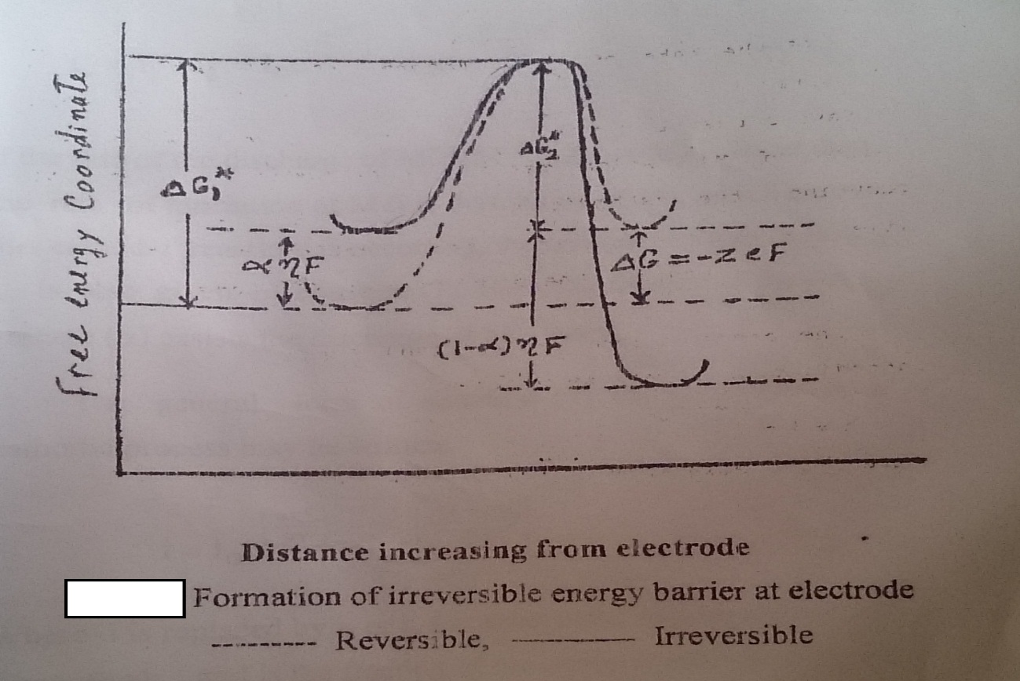

Answer of question (2): There are three types of polarization, resistance or ohmic polarization, activation polarization and concentration polarization.
Concentration polarization:
It is well known that in an electrolytic processes, the concentration of the electrochemically active materials in the immediate vicinity of the electrode is different from that in the bulk of solution, thus in cathodic deposition process, the concentration of metal ions around the cathode is smaller than that in the bulk of the solution and in anodic process the reverse is occurred. During the discharge of cations at the cathode, ions are brought to the electrode surface by three ways: i) ionic migration, ii) diffusion, iii) agitation (stirring or convection). IF the total supply of ions by (i) and (ii) is adequate, there no ionic transport by diffusion, but if the rate of electrolysis exceed that at which ions can be brought by (i) and (iii), then the electrolyte concentration at the electrode surface falls below in the bulk of the solution and ionic transport by diffusion takes place. An equilibrium is then reached in which a concentration gradient exist in a thin layer of solution (d) adjacent to the electrode. The position of this equilibrium is controlled by the rate of diffusion. The activity of the diffusing particles in the bulk is a and that at the electrode surface is a_{e} and the rate of diffusion is proportional with the difference between these two activities and is given by the following relation:
Rate of diffusion = D/d (a – a_{c})
in which D is the diffusion coefficient in cm²/sec. The value of D for most cations are near to the value 7.5x10⁻⁶ cm²/sec for H⁺ and OH⁻ ions they are several times greater than most ions. Besides transport of ions by diffusion, an electrolytic transport according to Faraday,s law occurs according to the following equation: Rate of electrolytic transport = n₊ i / ZF
In which n₊ is transport number of cations, i is current density in ampere / cm² , F is the Faraday constant (96500 coulombs). The total rate of transport (i/ZF) is given by the following relation:
i / ZF = D/d (a – a_{c}) + n₊ i / ZF
i / ZF - n₊ I / ZF = D/d (a - a_{e})
(1 – n₊) i / ZF = D/d (a – a_{e})
i = ZFD / (1 –n₊)d (a – a_{e})
From the last equation, as the value of i is increased value of a_{e} decreases and zero value of a_{e} corresponds to the maximum value of i, which is known as limiting current, i_{L}. In this situation, the limiting current is given by the relation:
i_{L} = ZFD a / (1 –n₊) d = ZFD a / n d
where n represents the sum of transport number of all ions which are discharged at the cathode. The last equation can be written as: i_{L} = k a ( where k is a constant)
Practically under the limiting current conditions the electrode potential increases until some different electrode reaction with a great limiting current is able to proceed such as hydrogen evolution. The general form of the relation between concentration polarization (overpotential) and current is shown in the following figure:
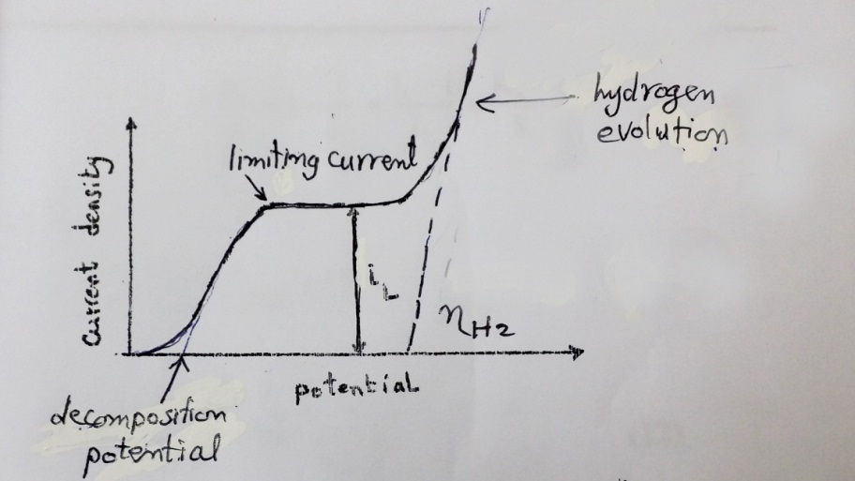

The section of the curve up to the limiting current in the figure is expressed by the following equation:
i- At the electrode surface, the potential is given by:
e = eº + RT / ZF ln a_{e}
ii- The reversible electrode potential is given by:
e_{rev} = eº + RT / ZF ln a
The concentration overpotential is given by:
Ƞ_{C} = e - e = RT / ZF ln a_{e} / a
By dividing equation 5 over equation 8 we get:
a_{e} / a = i_{L} - i / i_{L}, therefore ƞ_{C} = 2.303 RT / ZF log i_{L} - i / i_{L}

.
Answer of question (3):
The discharge of H⁺ to form hydrogen gas is one of the most important cathodic process. The
potential at which hydrogen is discharged is the reversible potential only at platinized platinum
electrode, with electrodes of the other material elevated &_{H} is required. The principles characteristic
of &_{H} are:
- It increases as the current density increases following approximately Tafel equation.
- It depends on the chemical nature of the electrode material as shown in the figure. The higher the catalytic activity a metal the lower the &_{H} on it.
- It depends on the surface state of the electrode (smooth, rough). A smooth platinum electrode is greater than a platinized electrode due to the greater surface area of the latter which allows the same rate of gas evolution to occur at a much lower current density.
- It decreases with increasing temperature,
- It depends on the pretreatment of the electrode surface.
- It depends on the presence of even traces of certain substances which act as catalytic poisons. For example the deposition of hydrogen at a contaminated surface usually takes place at a higher overpotential than a clean surface.
The essential stages in the overall process of hydrogen discharge and gas evolution may be assumed as follows:
- H₃O⁺ ions diffuse from the bulk solution to the edge of the double layer.
- H₃O⁺ ions are transferred across the double layer.
- Dehydration of H₃O⁺ . 4- H⁺ receives an electron from the electrode.
Stages (2), (3) and (4) represent the discharge reaction which may be as:
M + H₃O⁺ + e = M-H + H₂O ( H atoms adsorbed onto the electrode)
5-Formation of hydrogen molecule from hydrogen atoms. This can occur in one of two possible
ways:
- M-H + M-H = 2 M + H₂ (often called the catalytic reaction)
ii) M-H + H₂O + e = M + H₂ + H₂O (often called the electrochemical reaction)
6-Desorption of hydrogen molecule.
7-Formation of bubbles and evolution of hydrogen gas.
If stage 1 is the rate-determining step, the overall process would be diffusion controlled due to
concentration polarization. Usually, one of the stages (2), (3), (4) or (5) is the slowest step and it is
the rate-determining step depending on many factors such as the operating conditions and the nature
of the cathode.

Answer of question (4):
Stern showed that neither the compact Helmholtz nor the diffuse Gauy-Chapman theories are alone adequate and he developed a theory combining the essential characteristics of both theories. According to Stern the double layer consists of two parts: one of which is approximately a single ion in thickness of oppositely charged ions of the liquid remains almost fixed to the solid electrode surface and in this layer there is a sharp fall in potential and the second part extends some distance into the solution and is diffused associated with an exponential fall in potential, the charge may have a sign either the same or opposte from that of the adsorbed layer, The potential of the two parts may be of the same sign or of opposite sign depending on the characteristics of the ions present in solution and two models of Stern double are obtained as shown in the figure

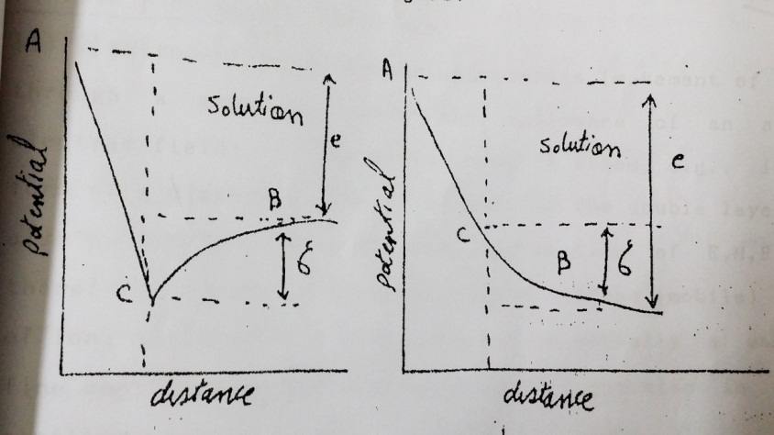

As shown in the figure AC in each represents a sharp fall of potential in the fixed part whereas CB represents the gradual change in the diffuse part of the double layer. The potential of the diffuse part of the double layer is denoted by £ (zeta) and is known as the electro-kinetic or zeta-potential, this potential is difference from the thermodynamic or the reversible potential (e). Four interesting effects which are ascribable to to the existence of a diffuse mobile double layer at the interface and grouped under the name electrokinetic phenomena. These phenomena are:
- Electro-osmosis: In which a movement of liquid through a membrane under the influence of an applied potential. If the solid face is fixed in the form of a diaphragm, the fixed part of the double layer will also be unable to move and the application of the emf will results in movement of the diffuse (mobile) layer of ions and liquid.
- Streaming potential: Which is the reversible of the or the potential difference electro-osmosis or the potential difference arising across a capillary tube or a membrane when m/sec and for water as a dispersion medium by plaining identical reversible electrodes, e,g. calomel electrode at each end of the capillary tube and determining the difference in potential where in water or any aqueous solution is forced through the tube. By considering the electrical double layer as a simple capillary , the streaming potential, S, is related to the electro-kinetic or z-potential using the following relation
£ = 4r k S µ / PD
where P is the pressure applied to the streaming liquid whose specific conductance is k, r is the radius of the capillary tube and D is the dielectric constant of the liquid. The values .of £ obtained varied between 0.02 – 0.05 V.
- Electrophoresis: Which is the migration of charged particles in an electric field, the relationship of zeta potential and the various parameters is given by:
£ = 4Iƞµ / D
where µ is the electrophoretic mobility of the particle and ƞ and D are the viscosity and dielectric constant of the medium, respectively For most colloidal particles µ equals to 2.4 x10⁻⁴ cm/sec and for water as a dispersion medium the streaming potential is 0.06 V.
- Dorn effect: Which is the reverse of electrophoresis, or the potential difference that is set up in a solution when particles are allowed to fall through it. The charge density of the Ster double equals to the summation of the charge denisities of Helmholtz and diffuse components q_{H} and q_{D.} The capacity CS of the Stern double layer is derived by treating it as two condensers in a series, thus:
q_{total} = q_{H} + q_{D}
1/ CS = 1/ C_{H} + 1/ C_{D}
where C_{H} and C_{D} are the capacities of Helmholtz and diffuse component, respectively.

Answer of question (5):
There are three different used for measuring the electrical double layer which are, the electro-capillary method, the tracing the build and the decay of electrode potential and AC bridge technique.
The electro-capillary method: This method depends on the study of the surface tension of a metal such as mercury in contact with inert salt solution. The Lippman electrometer shown in the following figure (a) is an apparatus used to construct electro-capillary curve (surface tension of mercury vs, potential of the mercury electrode which is coupled with a reference electrode such as calomel electrode). The apparatus consists of a column of mercury ends in a fine capillary tube which dips into a solution of the electrolyte containing also the reference electrode. The column is sufficiently high to bring the mercury meniscus in the capillary opposite a reference mark to be follow using a travelling microscope. The mercury in the column is connected to the negative end of the potentiometer. The interfacial tension between the mercury and solution is manifested as changes by displacement of mercury meniscus depends on the charge and hence the potential difference at the mercury solution interface. This is because similar charges repel one another and hence tend to expand the surface of mercury drop. The result is that the interfacial tension is lowered. As a general rule, in absence of applied EMF, the mercury has a positive charge. As the cathodic potential on the electrode increases, the charge is first diminished and neutralized, the surface tension increases and reaching a maximum value when there is no charge on the mercury drop. Further increase of cathodic potential developed a negative charge on the mercury surface and the surface tension again falls. The curve obtained (b) on plotting the surface tension at the y axis against the applied potential at the x axis is known as electro-capillary curve, the maximum of the curve is known as electro-capillary maximum. The potential of the electro-capillary maximum for mercury in aqueous solution is – 0.56 V vs. SCE. At the electro-capillary maximum (ecm), the charge on the mercury surface is zero, and hence the potential difference across the double layer, i. e., across the electrode-solution interface must be zero, q = CE = zero
The right hand side of the electro-capillary maximum, mercury is negatively polarized and on the left hand side mercury is positively charged. Hence specifically adsorbed anions e.g. halide ions exert their influence on the positive side of the zero potential, i.e., the left branch of the curve. The presence of active anion therefore shifts the ecm to more negative potential as shown in the following figure, while active cations e.g., tetramethyl or tetraethyl ammonium has the opposite effect. Thermodynamically, it has been found that the slope of the electro-capillary curve is equal to the charge density in the electrical double layer : d# / dE = q
At the ecm the slope of the curve is zero. The second difference of surface tension with respect to potential gives the difference capacity of the double layer:
C = dq / dE = d²# / dE²

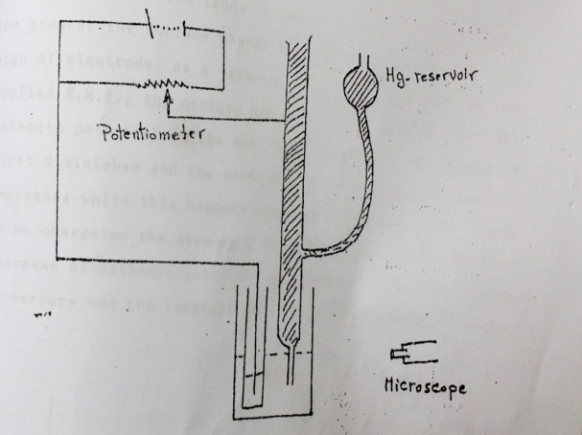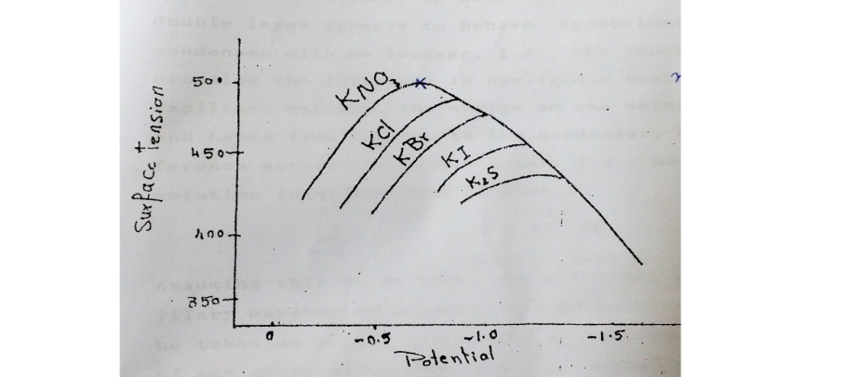
b
a

